

**Software Documentation for Group 5**

**29 June 2018**



**Members**:

* Liam Collins
* Austin Green
* ****John Mier
* Gabriel Pridham
* Michael Vasquez

**Summer 2018**

**COP4813 – Internet Programming**

**Professor Albert Ritzhaupt**

**<http://139.62.210.151/~group5/cop4813/index.php>**

**How to use the website**

**Account Creation:**

To create an account you can click the button in the top right corner labeled “Are you a trainer?” and select “*New Trainer”. There it has you type is a new name that hasn’t been entered before with normal characters. Then you just click “Register!” and your account has been created.

**Creating your party:**

To create a party, all you have to do is select the ring in the bottom right of a Pokémon’s entry and you’ll be able to add that to your dedicated party. Parties are individual to current Trainers, so you must be a Trainer in order to create your own party. You can deselect the Pokémon from your party if you click the pokeball icon that appears when you favorite them.

**Comparing Pokémon:**

Press the compare button located between the search bar and the filter. From there you can select up to two Pokémon entries to compare between. It will bring you to an individual page that shows the two Pokémon’s statistics side by side. Pressing the left will display the Pokémon that comes before each respective Pokémon. Pressing the right will display the next Pokémon after each respectively. The pokeball at the bottom is a home button that returns you to the pokedex.

**Individual Pokémon:**

Any Pokémon’s stats can be seen by clicking on its card from the front page. Similarly the left and right button at the show display the Pokémon to the left or the right of it. The pokeball again acts as a home button.

**Evolution:**

 The individual Pokémon page has an evolution button that only appears if a Pokémon has an evolution. If a Pokémon with no evolution is chosen then the button does not appear. By clicking the “Evolve” button, one is taken to that Pokémon’s next stage in the evolution of that Pokémon. Some Pokémon can have multiple evolutions (I.E. Eevee), this is handled by going through every evolution sequentially. So each evolution will go to its “sibling” of sorts. When arriving to the last stage of evolution of a Pokémon the button once again disappears as to show it can no longer evolve

**Searching and Filtering:**

With the Filter you can choose to filter between Pokémon type (in alphabetical order) and Pokémon’s entry number. The default filter is in numerical order. You can live search Pokémon and it will update to show you Pokémon based off of what you type in the search bar (I.E. searching “bulbasaur” will give you Bulbasaur, searching “bulbasaur**d**” will give you nothing).

**General Navigation:**

You’ll start on the main page viewing all of the Pokémon and when you select an entry it will bring you to their statistics page. On that page there will be at least one button, the Home button at the bottom which will look like a Pokeball, and the Evolve button as explained in the evolve section.

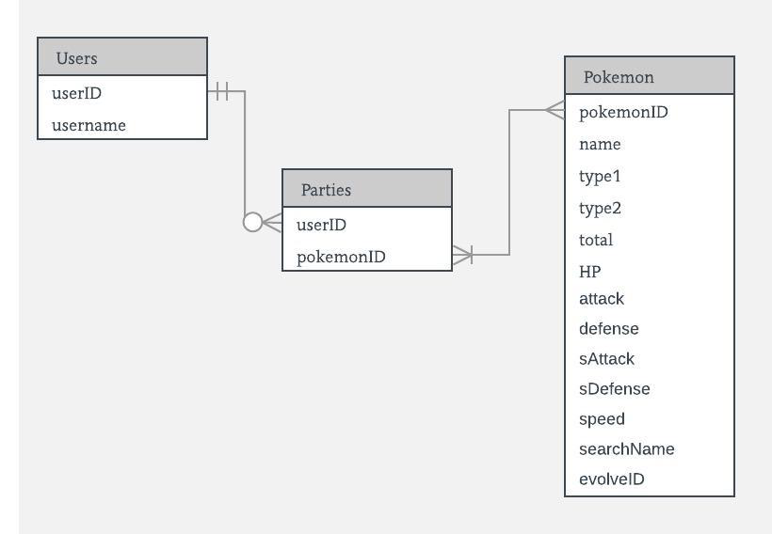**Entry Relationship Diagram (ERD)**